11/23/2015

**2016 preliminary herring forecast for Sitka**

Forecast, GHL, Harvest Rate and Fish Condition

The recommended preliminary 2016 forecast for Sitka Sound is 78,372 tons and the recommended preliminary GHL is 15,674 tons (20% harvest rate) (Figure 1 and 2). The mature biomass forecast is a 21% increase from the model estimate of 2015 mature (pre-fishery) biomass (64,660 tons) and a 40% increase from the model estimate of 2015 spawning (post-fishery) biomass (55,804 tons). The biomass trajectory in the 2015- and 2016-forecast models were virtually identical, however a slight increase in 2015 spawn deposition and large recruitment in 2015 resulted in the 2016 forecast being nearly double the forecasted biomass for 2015 (Figure 3). While the 2016 forecast and GHL are nearly twice that of 2015, they are very similar to those in 2014. The forecasted increase between 2015 and 2016 is due to a very large recruitment of age-3 fish in 2015. Age-3 fish comprised 48% of the cast net sampled mature fish in 2014 (Figure 4) and the model-estimated recruitment (number of mature and immature age-3 fish) for 2015 is the third largest recruitment since 1980 (Figure 5). The large proportion of age-3 fish in the 2015 mature population was seen across southeast populations. Age-4 fish are forecasted to comprise 65% of the Sitka mature population by number totaling 43,264 tons in 2016 (Figure 6 and 7). Whereas weight at age and length at age for many other southeast stocks have shown a decreasing trend over time, Sitka population weight and age and length at age have been stable over time, except for lower than average weight at age from 1989-1993 (see *Sitka weight length condition for 2016 forecast.xlsx*). Sitka condition factor has varied over time, with the lowest in the early 1990’s, and the highest in 1997, 2002, 2003, and 2009, and with 2015 being near the high end of the range (see *Sitka weight length condition for 2016 forecast.xlsx*).

Model Comparison Procedure

This year, thirty one models were run with various combinations of survival, maturity, and selectivity time-periods (one model structure with 31 different parameterizations; see *2016-forecast Sitka model comparison to post.xlsx*). The years in which model-estimated survival and maturity were allowed to change were in years of sea-surface temperature change, as measured by the Pacific Decadal Oscillation (PDO) Index (Mantua and Hare 2002). The PDO changed from warm to cold between 1998 and 1999, from cold to warm between 2002 and 2003, and from warm to cold between 2007 and 2008. A model with more than one time period for gear selectivity was only investigated was a corresponding change in maturity or if there were known and obvious changes in selectivity/fishing (I was not aware of any obvious changes in selectivity/fishing over the time series, but if you expect any, I would be glad to run a model that allows for that).

The relative fit of each model to the data was measured using an Akaike Information Criterion corrected for small sample sizes (AICc) (Burnham and Anderson 1998). The recommended model was chosen from among all models based on AICc values, number of parameters among models with similar AICc values, inspection of residuals, biologically realistic estimation of parameters, and continuity with prior forecasts (similar periods of change for survival, maturity, and selectivity as prior years). The difference (∆*i*) between a given model and the model with the lowest AICc value was the primary statistic for choosing the recommended model from among all the biologically reasonable models. Models with ∆*i* ≤ 2 are considered to have substantial support, those with ∆*i* between 4 and 7 have considerably less support, and models with ∆*i >* 10 have essentially no support (Burnham and Anderson 2004; see *2016-forecast Sitka model comparison to post.xlsx*).

Final Model Description

*Similar* to the 2015 ASA model, the recommended 2016 ASA model

1. was implemented in AD Model Builder,
2. is based on data starting from year 1980,
3. weights annual spawn deposition estimates by the inverse of their estimated variance (Figure 8),
4. has two survival estimates (58% survival for 1980-1998 and 76% survival for 1999-2015; Figure 9a),
5. has a single maturity schedule with an increasing percent of mature fish over ages (Figure 9b),
6. has a single gear selectivity schedule (Figure 9c),
7. uses the most recent survival (1999-2015) for the 2016 forecast,
8. uses the previous year’s winter test fishery mean weight at age as the forecast weight at age (Figure 10)
9. incorporates a Ricker spawner-recruit function that is weighted low in the objective function (same weighting as recent years) and helps the model to run smoothly, but has virtually no influence on model fit (Figure 11), and
10. uses the Ricker spawner-recruit function to forecast age-3 recruitment in 2016 (Figure 6).

Despite the large number of alternative models in 2016, the range of GHL’s produced by these models was quite small, varying by only approximately 2,000 tons. There were two models that fit nearly as well as the recommended model (see *2016-forecast Sitka model comparison to post.xlsx*). The differences in AICc (∆*i*) between these models and the recommended model were 0.74 and 1.85. These models both had a change in survival between 1998 and 1999 and either had a change in maturity between 2007and 2008 or between 1998 and 1999. The GHL’s produced by these models were 13,788 tons and 14,492 tons, respectively. The recommended model was chosen using consistent rationale with other years and other stocks. Specifically, it was chosen because of the model fit (lowest AICc value), the lowest number of parameters among models with similar fit, and continuity in model parameterization with previous years (i.e. the recommended model this year fit the data best last year, whereas the model with the second lowest AICc this year did not fit the data very well last year).

Extra Figures

Figures were automated in the program R from AD Model Builder so that ASA herring forecasts for all southeast stocks assessed with ASA models have similar outputs of figures. If there are additional figures you would like to see, or changes to the current figures (layout, color, bars versus points/lines), please let me know. I will also put an updated copy of the summary file under S:\Region1Shared-DCF\Research\Herring-Dive Fisheries\Herring\Year 2016 Forecasts\Forecast models\ ASA Models\Sitka. AWL and spawn deposition files are included in the Year 2016 Forecasts subfolders as well.

I look forward to hearing your thoughts,

Sherri

**References:**

Burnham, K. P., and D. R. Anderson. 2004. Multimodel Inference: Understanding AIC and BIC in Model Selection. Sociological Methods & Research, Vol. 33(2): 261-304.

Burnham, K. P., and Anderson, D. R. 1998. Model Selection and Inference. Springer, New York. 353 pp.

Mantua, N. J. and S. R. Hare. 2002. The Pacific Decadal Oscillation. Journal of Oceanography, 58: 35-44.

**Figures** 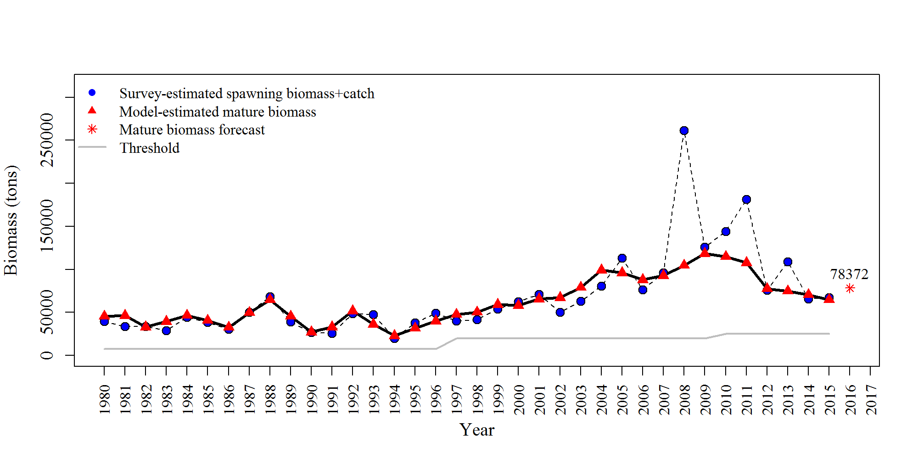

**Figure 1:** Survey-estimated spawning biomass plus catch (tons), model-estimated mature biomass (tons), and model-estimated mature biomass forecast (tons). There are minor differences in the survey-estimated spawning biomass plus catch in last year’s (2015 forecast) and this year’s (2016 forecast) plot. Last year survey-estimated eggs were converted to biomass using a constant age composition and weight-at-age over the time series. This year the survey-estimated eggs were converted to biomass using year-specific age composition and weight-at-age over the time series (i.e. this year’s survey estimated spawning biomass matches the spawn deposition file for each year).

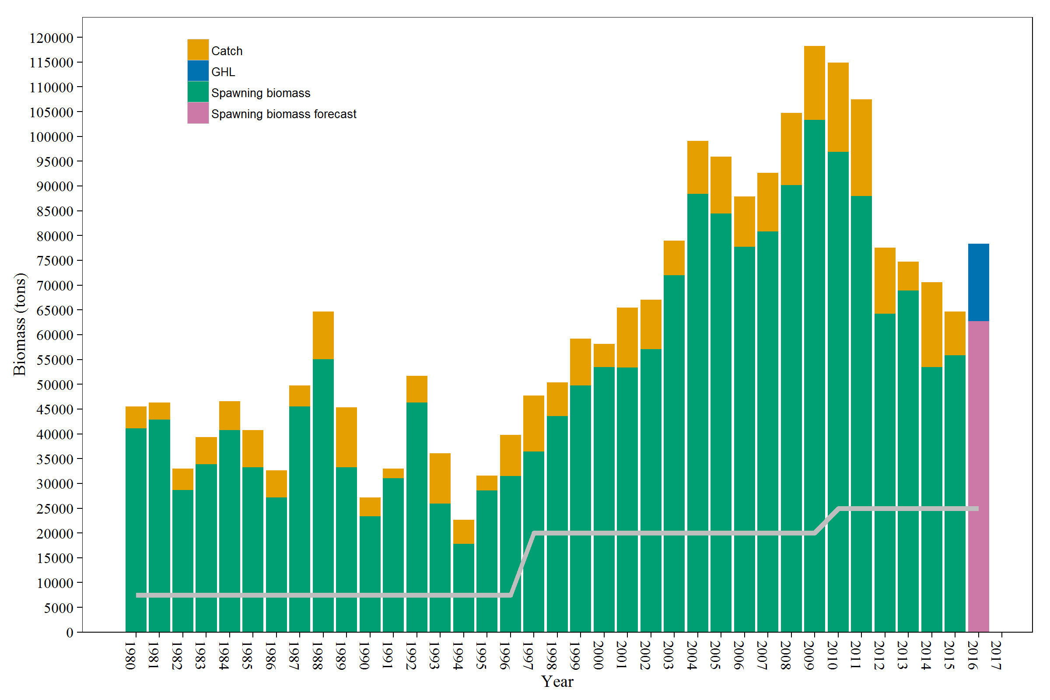

**Figure 2:** Stacked bar graph of catch (orange), spawning biomass (green), GHL (blue), and the spawning biomass forecast (pink) along with the threshold (grey line). The harvest (or GHL) plus the spawning biomass equals the mature biomass.If there is no catch (or GHL), the spawning biomass (or spawning biomass forecast) equals the mature biomass (or mature biomass forecast). There is a minor difference in the 1997 catch between last year’s (the 2015 forecast) and this year’s (the 2016 forecast) because the 1997 catch in last year’s figure was calculated with average 1997 cast net weight at age so the catch biomass was likely underestimated and this year was estimated with average 1997 weight at age from the commercial seine harvest. This difference affects only this graph and not any calculations that affect the forecast and GHL.

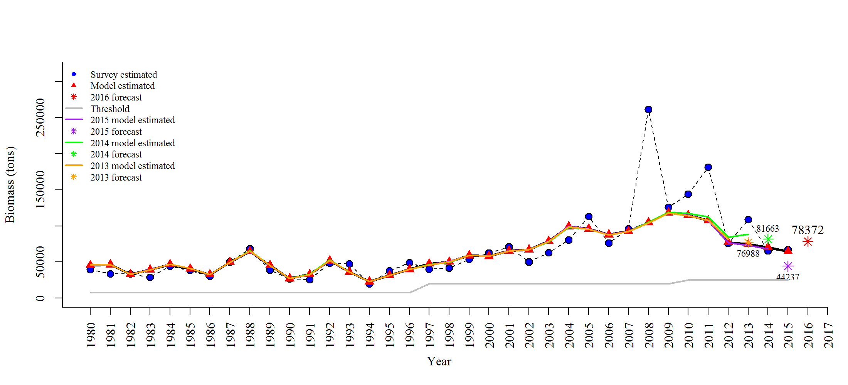**Figure 3:** Comparison of past and current survey-estimated mature biomass (survey-estimated spawning biomass plus catch), model-estimated mature biomass, and model-estimated mature biomass forecasts (tons).

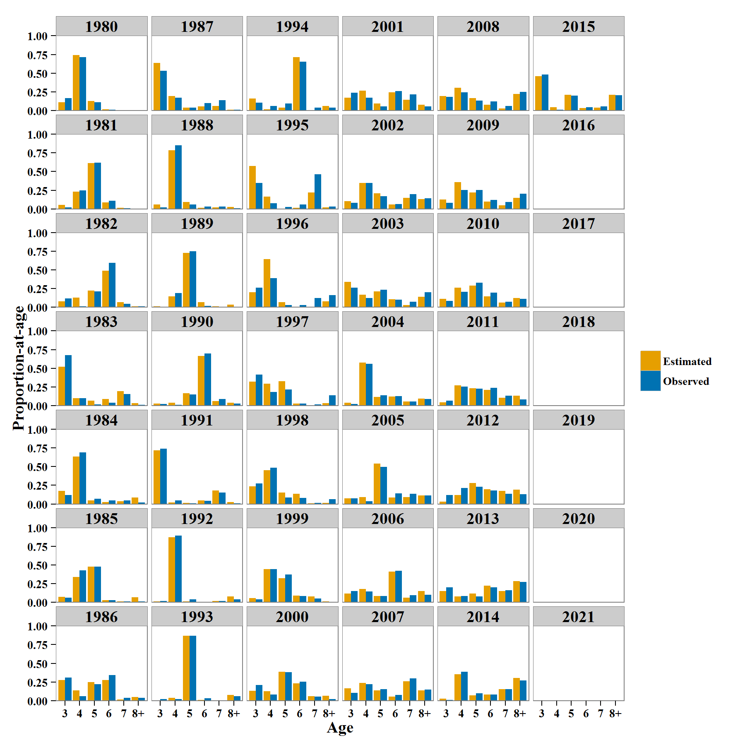

**Figure 4:** Observed cast net (blue bars) and model-estimated (yellow bars) spawning-age composition.

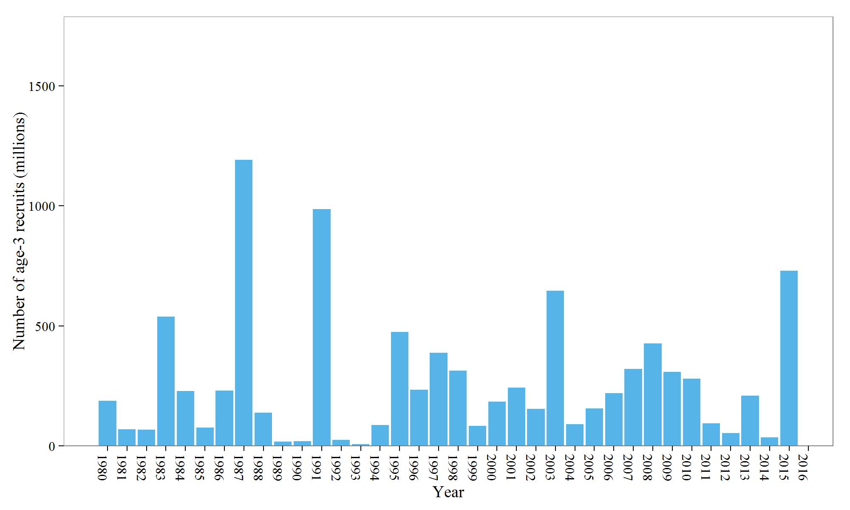**Figure 5:** Model estimates of age-3 recruit strength (numbers of age-3 mature and immature fish).

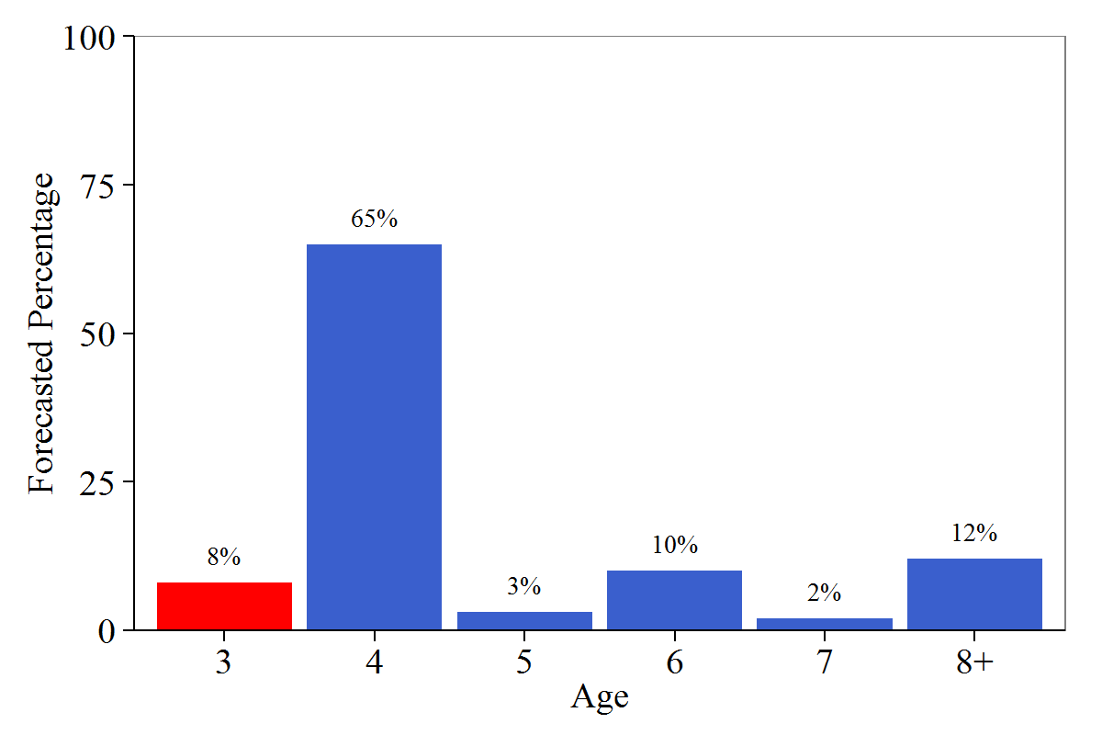

**Figure 6:** Forecasted percentage of mature numbers at age for forecast year. The percent of age-3 fish was estimated with a Ricker spawner-recruit function (red bar).

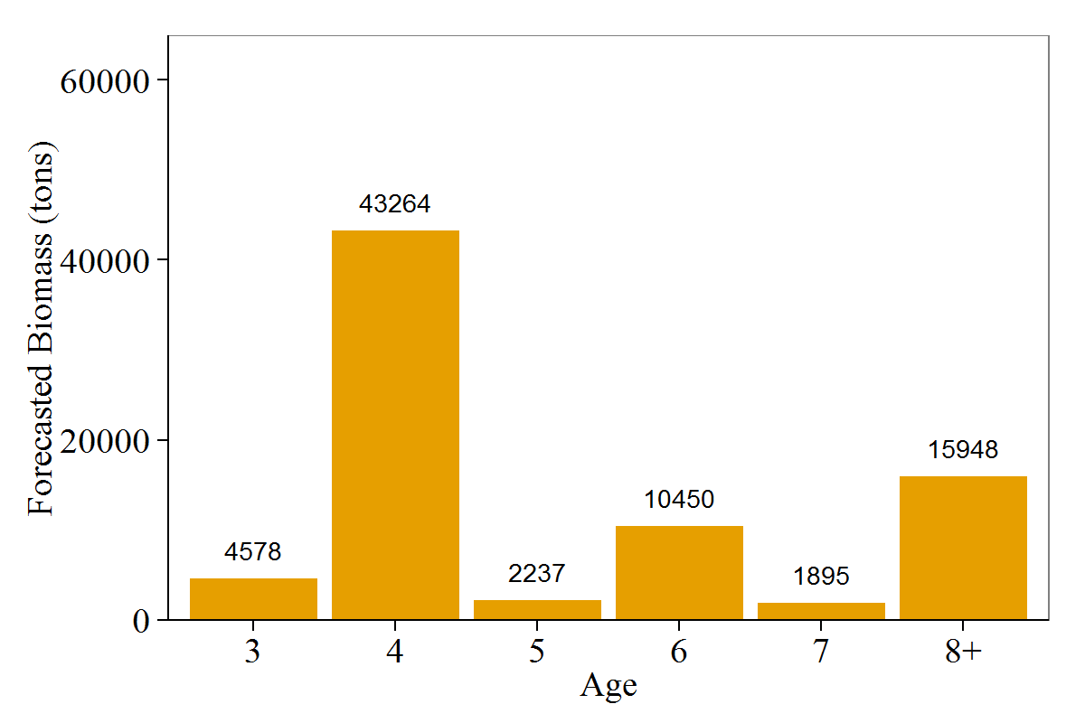

**Figure 7:** Forecasted mature biomass at age (tons) for forecast year.

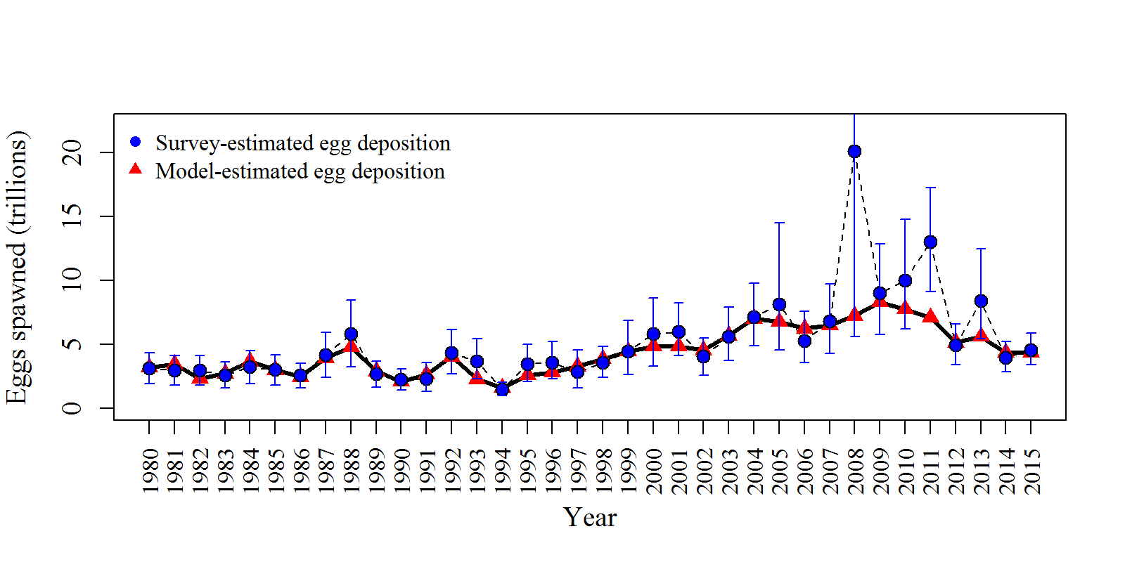**Figure 8:** Survey-and model-estimated egg deposition. Survey estimates have 95% confidence limits. Confidence limits from 1991-2015 are based on bootstrap analysis. Standard deviations for 1980-1990 are estimated based on a linear regression of ln(egg numbers) to ln(standard deviation) of 1991-2015 data. Confidence limits for 1980-1990 are based on two standard deviations around the mean. The upper confidence limit for the 2008 survey-estimated egg deposition (29.06 trillion eggs) is not shown to better view the other years.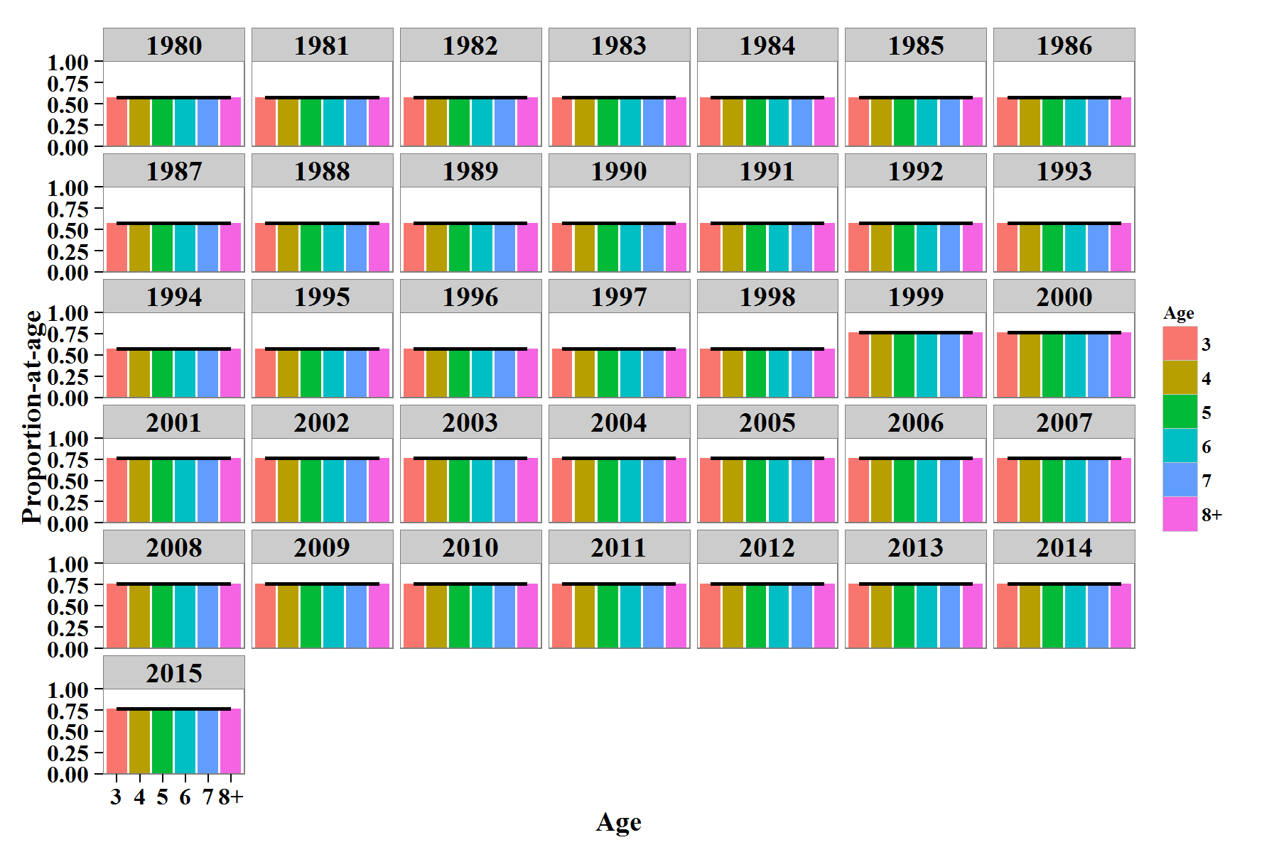 **Figure 9a:** Model estimates of survival by year.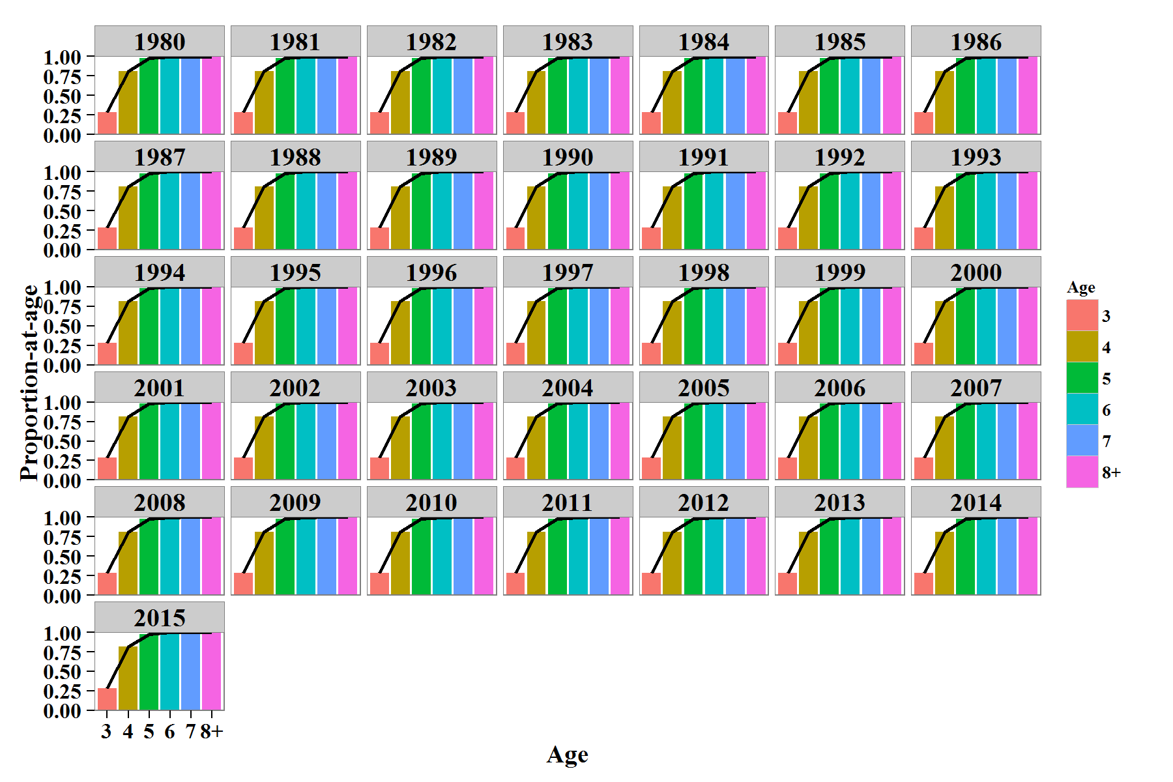 **Figure 9b:** Model estimates of maturity at age by year. 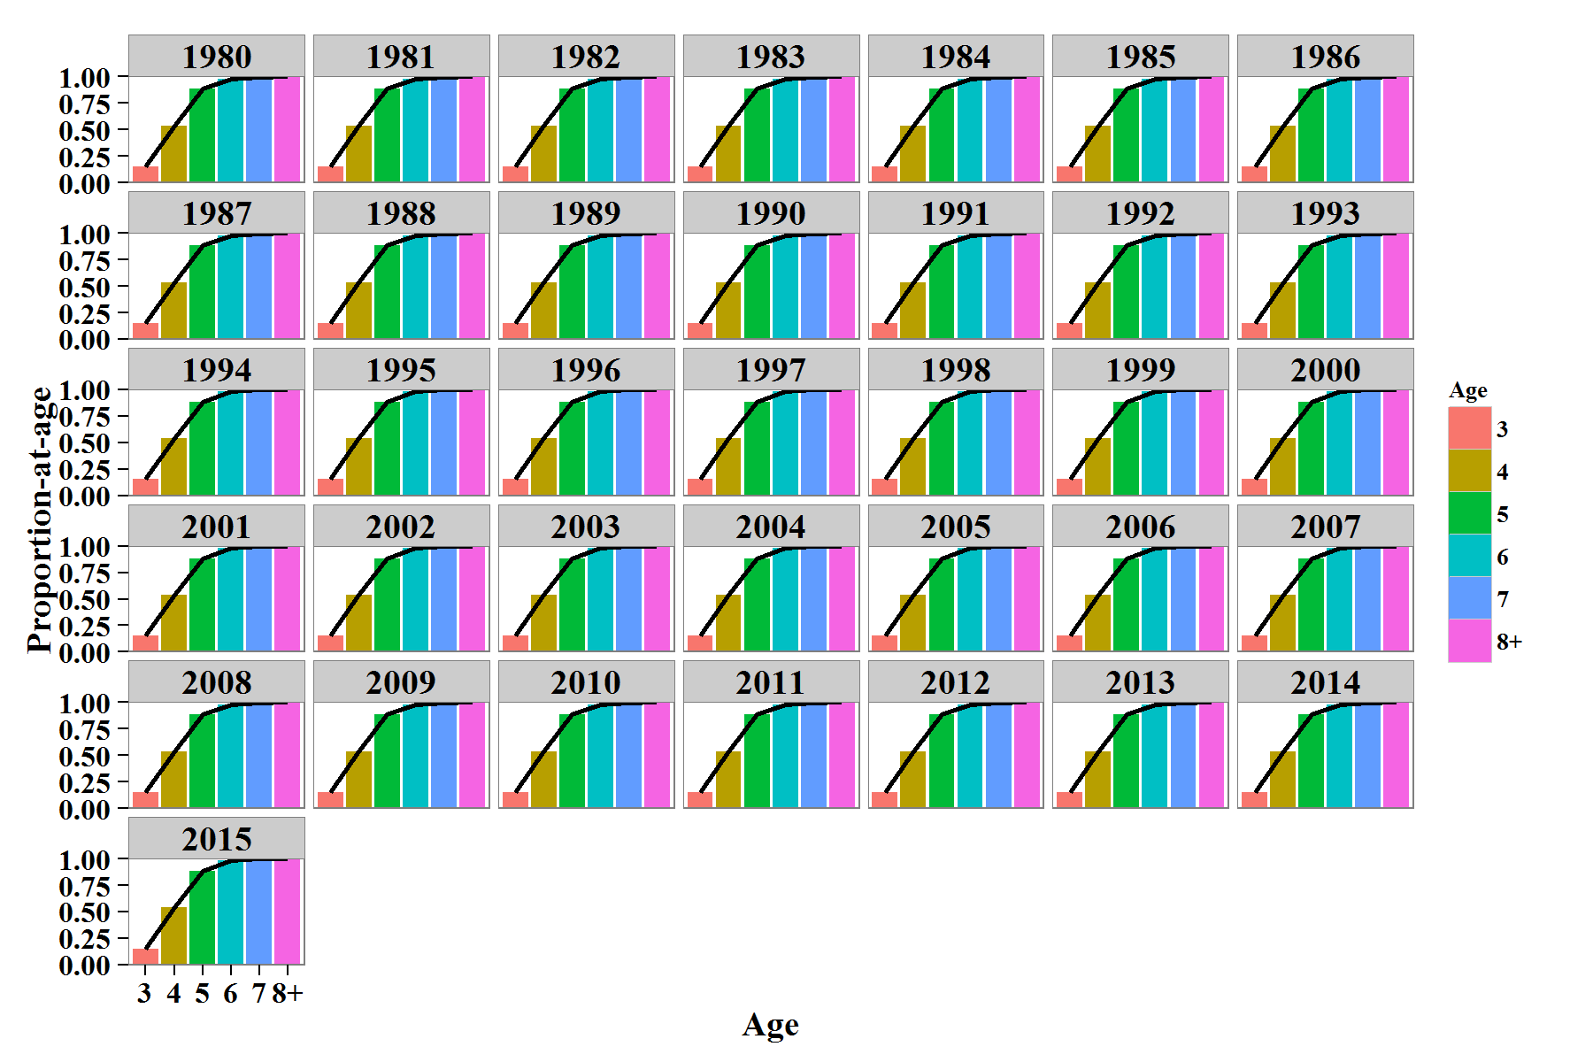 **Figure 9c:** Model estimates of seine gear selectivity at age by year.

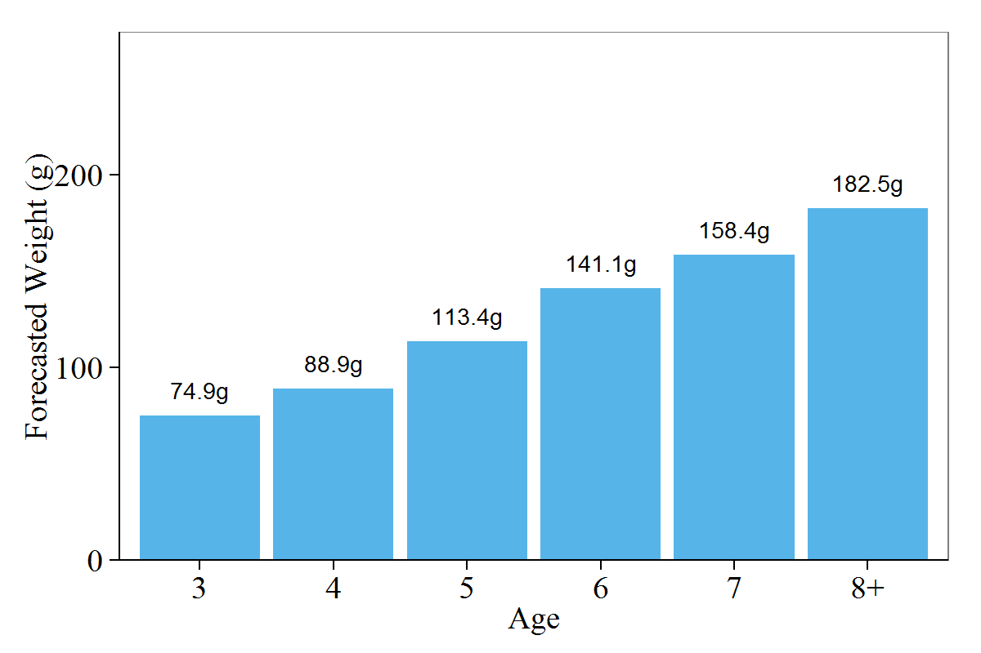

**Figure 10:** Forecasted weight at age (weight at age from the 2015 winter test fishery). 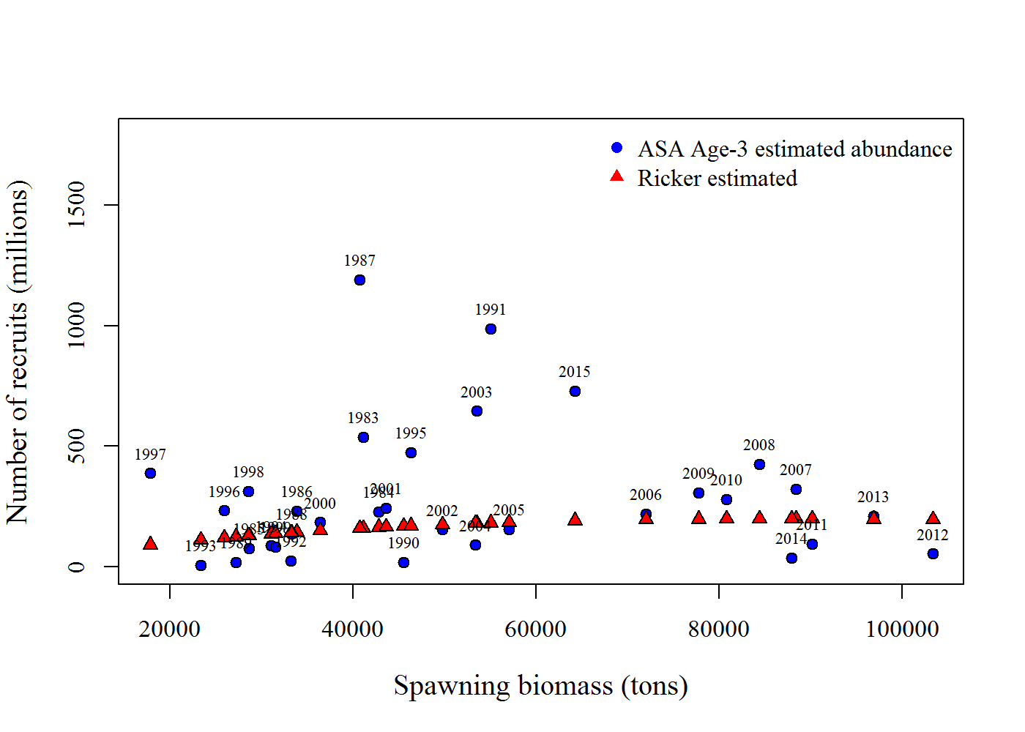**Figure 11:** Spawning biomass (tons) versus age-3 abundance (millions of mature and immature fish) (blue circles) with Ricker-estimated age-3 abundance (red triangles)*.*

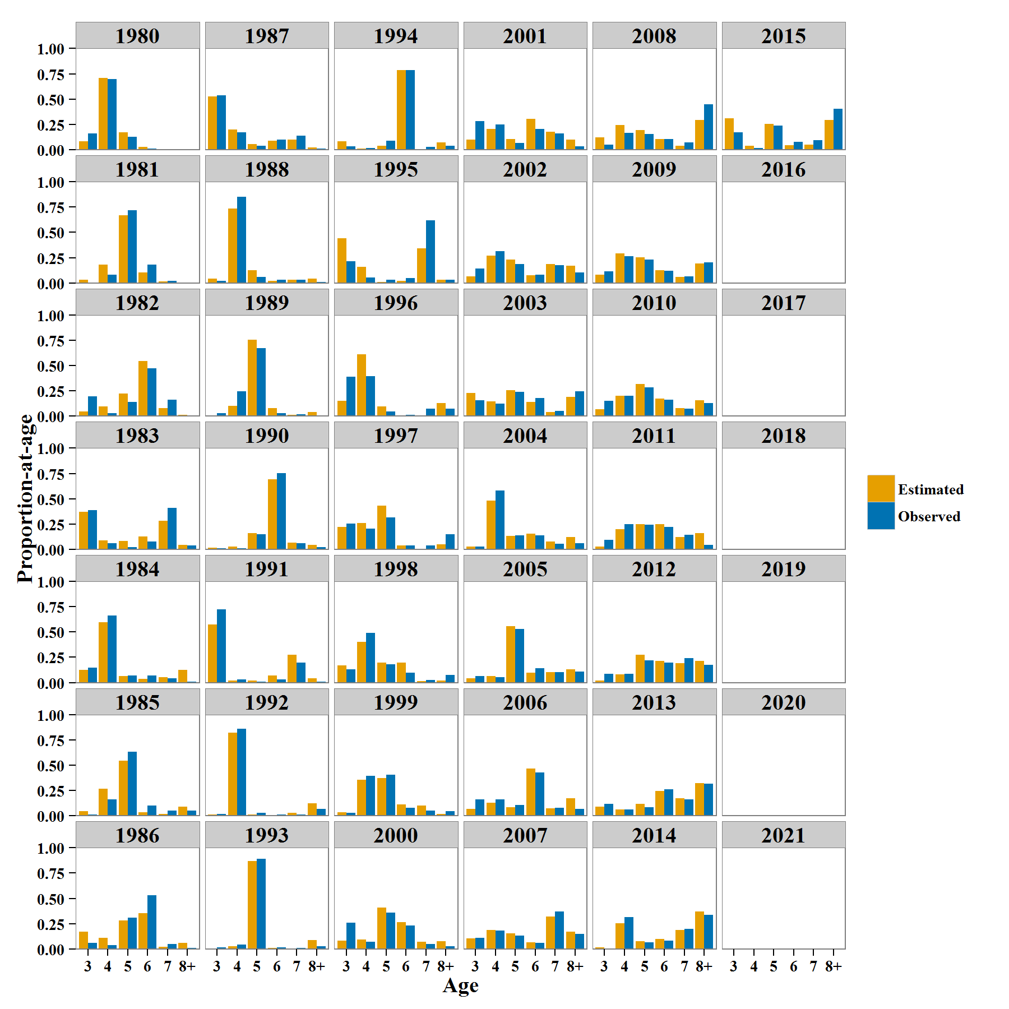**Figure 12:** Observed seine (blue bars) and model-estimated (yellow bars) catch-age composition.

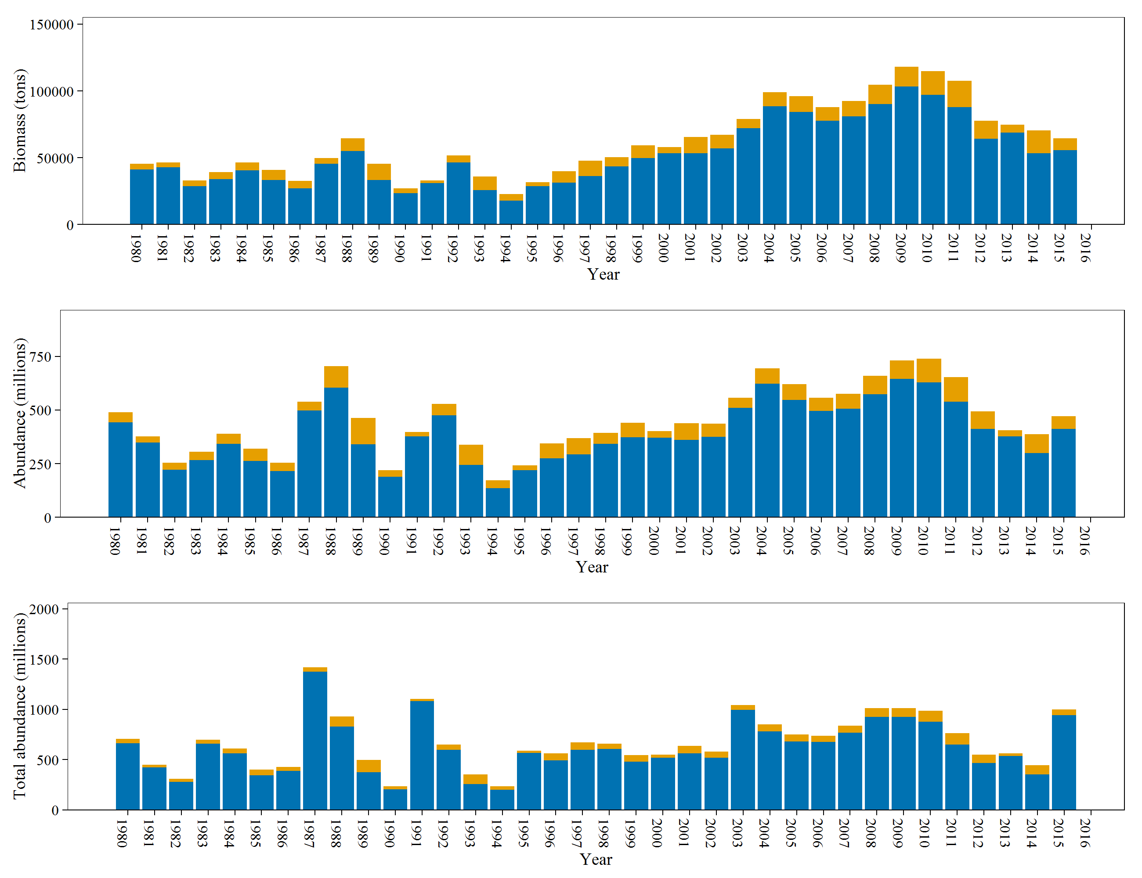**Figure 13:** Spawning population biomass (blue bars; top figure), spawning population abundance (blue bars; middle figure), total population abundance (immature and spawning abundance) (blue bars; bottom figure), and commercial fishery harvest (yellow bars) over time. The combination of the blue and yellow bars (total height of each bar) is the mature biomass, mature population abundance, or total population abundance.

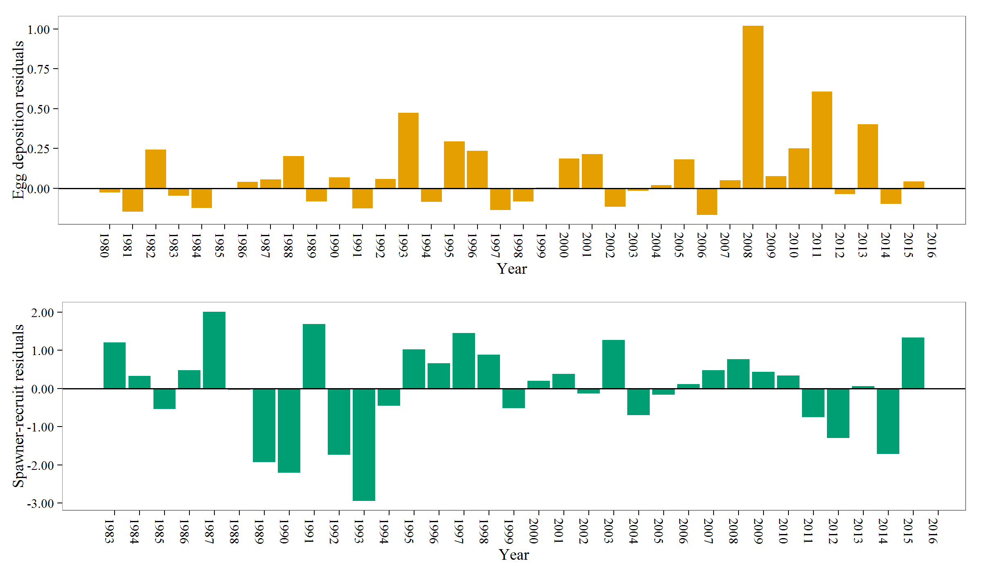**Figure 14:** Residuals from model fits to survey egg deposition (top) and Ricker spawner-recruit function (bottom).